1. **What is Imbalanced and balanced dataset?**

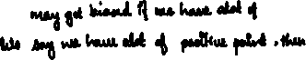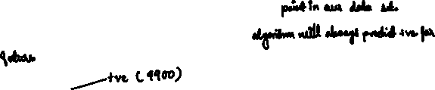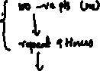

1. **Define Multi-classclassification?**



**# KNN Given a distance measure.**



1. **How to determine if data is changing over time? Or Distribution (Dtrain) != Distribution (Dtest)?**



1. **Explain Impact of Outliers?**



1. **What is LocalOutlier Factor?**

